Design of Mn(II) e Ni(II)-NHC complexes as photocatalysts for radical polymerization under visible light and 3D printing

B. E. Goi^{1*}, C. Bignardi¹, N. Pesqueira¹, Y. M. Shimizo¹, V. P. Carvalho-Jr¹, Jacques Lalevée²
¹Department of Chemistry and Biochemistry, FCT-UNESP, Presidente Prudente, Brazil ²Institut de Science des Matériaux de Mulhouse, Université de Haute Alsace, France beatriz.goi@unesp.br
+55 (18) 98122-1673

In recent years, metal-based photocatalysts have emerged as key players in the development of efficient photopolymerization processes and 3D printing technologies. This work highlights the design and photochemical evaluation of two new photocatalytic systems based on first-row transition metals coordinated to N-heterocyclic carbene (NHC) ligands: a manganese(II) complex [Mn(PyImes)2](PF6)2 and nickel(II) complexes [Ni(Py-NHC)2](PF6)2 and [Ni(Ph-NHC)2] (Figure 1). These complexes exhibit visible-light absorption and
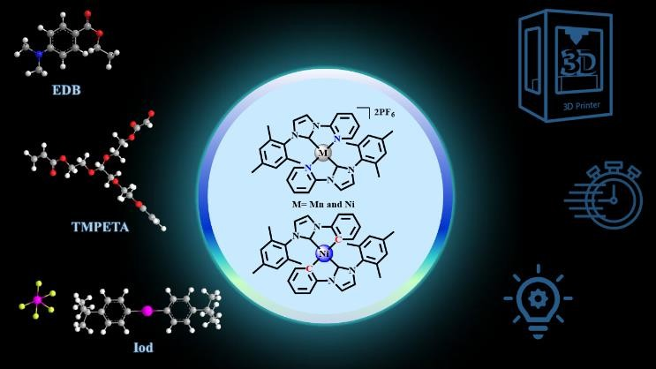
photoluminescence properties, making them suitable candidates for photoinduced free radical polymerization (FRP) and controlled radical photopolymerization (CRP2). The Mn(II) complex showed effective activation under LED (405–532 nm) and was successfully applied in laser-assisted 3D printing. Similarly, Ni(II)-NHC complexes demonstrated excellent
Figure 1. Photoinitiating system with NHC-Metal and 3D printing
performance under 405 nm irradiation, with high monomer conversions and remarkable resolution in 3D patterns. Mechanistic investigations supported by cyclic voltammetry, ESR, fluorescence quenching, and photolysis experiments confirmed their role as efficient photocatalysts via both oxidative and reductive pathways. These findings underline the potential of earth-abundant metal complexes as sustainable alternatives to precious metal- based systems in advanced manufacturing.

Beatriz E. Goi holds a Ph.D. in Physical Chemistry from the University of São Paulo (2006), with research stays in Spain (CSIC, Madrid) and Belgium (Université de Liège). She is currently an Associate Professor at UNESP – Presidente Prudente and a researcher at the Center for the Development of Functional Materials. Her expertise includes photochemistry, photocatalysis, photopolymerization, and 3D printing using organometallic complexes. She leads the LaCOM research group and serves

as vice-director of the Photochemistry Division of the Brazilian Chemical Society. Dr. Goi is an active member of national and international scientific networks.

Theme and Type of presentation: photocatalysis and advanced materials – oral presentation
Mode of presentation: In-Person

